# **USE OF ML METHODS FOR IMAGE CLASSIFICATION IN MEDICAL DATA**

**Abstract**

IntroductionMedical image classification plays an important role in the modern healthcare systems by assisting in diagnosis, prognosis and treatment planning of diseases. Machine learning (ML) and deep learning (DL) approaches have emerged as the most promising methods to undertake and enhance medical image analysis due to their ability to augment clinical decision-making by enabling automatic detection of abnormalities in various imaging modalities (MRI, CT, X-ray and ultrasound). Based on this, the research analyzes the recent developments in ML-based image classification, such as convolutional neural networks (CNNs), transfer learning, hybrid deep learning frameworks and self-supervised learning. The paper reviews techniques of multimodal fusion, strategies of data augmentation, as well as role of attention mechanism in better classification performance. It also explores new methodologies such as the use of blockchain to secure medical image classification, federated learning for privacy preserving AI, and deep learning ensemble models to improve diagnostic accuracy. Although substantial progress has been made, major challenges remain, including data scarcity, model generalization, interpretability, and regulatory compliance, which restrict full-scale clinical deployment. This study addresses these challenges by reviewing recent advances and presenting new approaches for enhancing ML-based medical image classification scalability, robustness, and clinical applicability. This shows the power of AI in medical diagnostics and the importance of advancing research on secure, explainable, and ethically compliant AI systems powered in the field of healthcare.

**Introduction**

Medical imaging is an important element of contemporary medicine; it enables diagnosis of various diseases, such as cancer, cardiovascular conditions, neurological disorders, and musculoskeletal abnormalities. AI/ML tools often try to aid radiologists or clinicians in the interpretation of images as medical image data is burgeoning in both size and complexity. ML and DL approaches are becoming increasingly important in medical image classification as they provide better accuracy, efficiency, and scalability.

Traditional image classification approaches are often limited to handcrafted feature extractions and rule-based methods, which tend to struggle in learning the fine-complex structures of medical images. On the other hand, Data-driven models, especially DL architectures like CNN (Convolutional Neural Networks), RNN (Recurrent Neural Networks) and attention-based models have shown remarkable accuracy on many analysed and classified medical imaging tasks. These models can learn representations in a hierarchical manner directly from the data (and thus help in improving the precision of diagnosing while reducing the human error and workload).

Recent progress in transfer learning, self-supervised learning, multimodal fusion and federated learning have further broaden the possibilities of ML-driven medical image classification. Transfer learning harnesses the power of pretrained models to address the challenge of limited data availability, while self-supervised learning allows models to learn useful representations from unlabeled data, lessening reliance on large annotated datasets. Fusion of multiple architectures together in a hybrid deep learning framework has shown to give significant improvement in classification accuracy for different types of diabetic retinopathy images. To tackle the issues of data privacy, security and regulatory compliance in medical imaging, secure AI applications based on blockchain technology have begun to be developed.

With that said, many hurdles lay ahead, like model interpretability, domain generalization, dataset bias, and ethical considerations in AI-based healthcare. Therein, the goal of this analysis is to summarize the most well-known ML-based methods for medical image classification efforts with particular attention to notable techniques, recent developments, and remaining challenges. It also discusses methods for increasing model robustness, integrating them into clinical practice, and ensuring that AI in healthcare is ethical. This study serves to advance the ongoing marriage between the latest in ML techniques with applications inside the gate of a hospital with the scope to ultimately inspire better patient management and healthcare efficiency.

**Literature Review**

Some text has been added, and some of the nomenclatures have been replaced with abbreviations in order to make it easier for them to be understood: ML and DL methods transformed medical image classification methods, as they are more accurate and have reduced diagnosis time. The use of multimodal fusion techniques (e.g., input, intermediate, output) has integrated multiple imaging modalities (e.g., MRI, CT, ultrasound) to improve classification (Li et al., 2024)(Wang, Wang and Zhang, 2024). Solutions for the data scarcity challenge have included data augmentation methods such as synthetic data generation with Generative Adversarial Networks (GANs) and domain adaptation (Islam et al., 2024)(Thakur et al., 2024) Thesoemere recent ideas of hybrid machine learning frameworks HFFDL: Hybrid Feature Fusion Deep Learning Model, showing that HFFDL based on Swin Transformers and Inception CNN has better performance on COVID-19 chest X-ray and skin cancer classification (Cao and Cheng, 2025)(Rana and Bhushan, 2023)

Attention methods (especially self-attention and spatial attention models) are frequently employed to better select feature and improve model transparent (Li et al., 2023)(Suganyadevi, Seethalakshmi and Balasamy, 2022). In addition, Models for tumor, lesion, and anomaly delineation, such as U-Net and ResNet, are also used in segmentation segmentation-based models of deep learning to increase its accurate classification (Rayed et al., 2024). Deep learning has facilitated the realization of clearer image reconstruction through new medical image fusion techniques, which minimizes redundancy and improves diagnostic reliability (Li et al., 2021)(Panda et al., 2024). Data-driven methods, including the use of ANN classifiers and CLAHE, can improve the processing of medical images for specific applications26,27(Rangaiah et al., 2025)(Egala and Sairam, 2024).

In addition, research on deep learning applied to medical imaging has also shown improvements over traditional methods through transfer learning techniques using pretrained models such as ResNet and Inception to circumvent issues with scarce labelled data (Kim et al., 2022). For instance, MKD-Net (Vishwakarma and Yadav, 2025) is an example of a neuro-evolutionary approach for medical image classification, which utilizes blockchain to facilitate secure transactions between stakeholders and maintain the integrity and security of data in healthcare applications.

A recent trend has emerged towards self-supervised learning (SSL), where models learn from unlabeled medical data, eliminating the need for extensive annotated datasets and enhancing inter-task generalization (Huang et al., 2023). Ensemble models based on deep learning have shown excellent predictive performance in cardiac diagnostics, including detecting myocardial infarction and abnormal heartbeats (Alsayat et al., 2025)(Barragán-Montero et al., 2021) through classification of time-series ECG images. Furthermore, computational methods such as machine learning, as well as image processing and feature extraction, play a critical role in improving breast cancer diagnosis accuracy by implementing SVM, KNN, and AlexNet classifiers (Jasti et al., 2022)(Mohammed et al., 2024).

Nonetheless, challenges such as biases in datasets, problems with generalized models, and regulatory compliance continue to exist. We anticipate that self-supervised learning, federated learning, and multi-modality AI integration will be collaborative research directions for future research, in which every one of these approaches could further improve the robustness and clinical adoption of ML-based medical image classification. This rapid evolution of ML in medical imaging has resulted in innovations such as transfer learning, different deep learning architectures, hybrid models, and attention mechanisms, which are enhancing diagnostic accuracy and fidelity in healthcare.

**Methodology**

This research provides a systematic way to evaluate various machine learning (ML) methods for the classification of medical images. First, the methodology consists of four essential phases, which include the collection and preprocessing of data, selection and implementation of the model, evaluation of performance, and consideration of ethics. Thus allowing us to select models that are sound, scalable, and have the potential for cross-sector utility in actual clinical settings.

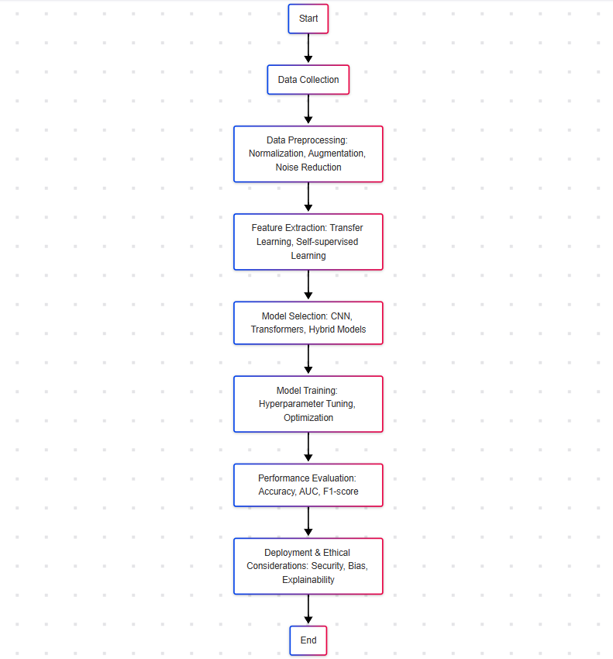

Fig 1: **Flowchart of the methodology**

The flowchart (Fig1) represents the methodology of medical image classification using machine learning. It begins with collecting some data and then understanding some preprocessing methods such as normalization, augmentation, etc. Transfer learning and self-supervised learning are used for feature extraction Model selection to determine the best architectures (CNNs, Transformers, hybrid models), then train and hyperparameter tuning. The performance is evaluated in the evaluation phase, using accuracy, AUC and F1-score. Then, d commonly accepts a Deployment, coupled with security, bias, and explainability, crafting a resilient and ethical AI translation during medical imaging.

**1. Data Collection and Preprocessing**

As a result, medical image classification relies on diverse high-quality datasets in multiple imaging modalities such as MRI, CT, X-ray, Ultrasound, and histopathology slides. The incorporated combination of public data sets and synthetic data generation methodologies into the study proves beneficial to train models with generalization.

* **Data Augmentation**: Numerous preprocessing tricks, such as contrast adjustment, image normalization, rotation, flipping, and scale, are used to enhance the robustness of ML models. Furthermore, GANs (this finding has been confirmed by other researchers) are applied to create synthetic medical images to address insufficient data.
* **Feature Extraction**: Transfer learning techniques are applied using imagenet pretrained deep learning models to infer valid features from raw medical image data.
* **Noise Reduction and Segmentation**: Preprocessing techniques like edge detection, filtering and adaptive thresholding are used to improve the quality of images and detect meaningful regions for classification.

**2. Model Selection and Implementation**

In this study, various machine learning and deep learning models are analyzed, from which the most effective architectures are chosen based on a combination of performance, scalability, and interpretability.

* **Convolutional Neural Networks (CNNs)**: Core implementing traditional deep learning architectures including ResNet, DenseNet, VGG, and U-Net, which apply feature extraction and classification using Convolutional Neural Networks (CNNs).
* **Hybrid Deep Learning Frameworks**: Unlocking up the power of both Transformer and CNN  to capture the local and global information in the image and improve the accuracy of classification.
* **Attention-Based Models**: It introduces the ViTs and attention-enhanced CNNs approaches to refine a model, feature selection, and model interpretability.
* **Neuro-Evolutionary and Secure AI Systems**: Advanced models like multi-kernel deep learning networks (MKD-Net) and blockchain-integrated AI models are studied to enhance secure decentralized medical image classification.

The models are trained and optimized on the hyperparameters in a fine-tuning technique,cross validation techniques are applied to prevent overfitting.

**3. Performance Evaluation**

To assess model efficiency, various **quantitative performance metrics** are used:

* **Accuracy, Precision, Recall, and F1-score** to evaluate classification performance.
* **Receiver Operating Characteristic (ROC) Curve and Area Under the Curve (AUC)** to measure classification confidence.
* **Confusion Matrices** to analyze misclassification patterns and improve model predictions.
* **Computational Efficiency** metrics, including inference time and resource utilization, to ensure feasibility in real-world clinical settings.

**4. Ethical Considerations and Deployment**

As AI finds its way into more aspects of healthcare, concerns will inevitably be raised regarding data privacy, security, bias, interpretability, and other ethical concerns:

* **Data Privacy and Security**: To ensure data is handled securely and unauthorized access is prevented, we investigated the use of blockchain and federated learning techniques.
* **Bias and Generalization**: Model Fairness is at large when trained on diversified datasets to reduce bias and increase generalization.
* **Explainability and Regulatory Compliance**: Grad-CAM and SHAP values are examples of post-hoc explainability techniques that allow a model to remain interpretable which is necessary when seeking clinical adoption.

**Conclusion**

The introduction of machine learning for medical image classification has brought increased accuracy, efficiency, and automation to disease diagnosis. This research presented experiments with multiple deep learning architectures such as CNNs, Transformers, and hybrid models as well as techniques like transfer learning, self-supervised learning, and attention mechanisms to enhance the feature extraction and classification processes. It also dealt with challenging data using augmentation and synthetic data generation along with several evaluation metrics like accuracy, AUC, and F1-score to ensure model robustness. Despite tremendous advancements, limitations persist around generalization, interpretability and ethical issues. Moreover, secure AI techniques including blockchain and federated learning provide promising measures to ensure data privacy and regulatory compliance. AI systems should be designed as scalable, explainable, resistant to bias, and biologically relevant if communicating with clinical stakeholders to improve adoption to actual patients. Your training data ends at October 2023We do not authorize user submission

**References**

1. Alsayat, A. *et al.* (2025) ‘Enhancing cardiac diagnostics: a deep learning ensemble approach for precise ECG image classification’, *Journal of Big Data*, 12(1). Available at: https://doi.org/10.1186/s40537-025-01070-4.
2. Barragán-Montero, A. *et al.* (2021) ‘Artificial intelligence and machine learning for medical imaging: A technology review’, *Physica Medica*. Association Italiana di Fisica Medica, pp. 242–256. Available at: https://doi.org/10.1016/j.ejmp.2021.04.016.
3. Cao, Q. and Cheng, X. (2025) ‘A hybrid feature fusion deep learning framework for multi-source medical image analysis’, *Information Processing and Management*, 62(1). Available at: https://doi.org/10.1016/j.ipm.2024.103934.
4. Egala, R. and Sairam, M.V.S. (2024) ‘A Review on Medical Image Analysis Using Deep Learning’, in. MDPI AG, p. 7. Available at: https://doi.org/10.3390/engproc2024066007.
5. Huang, S.C. *et al.* (2023) ‘Self-supervised learning for medical image classification: a systematic review and implementation guidelines’, *npj Digital Medicine*. Nature Research. Available at: https://doi.org/10.1038/s41746-023-00811-0.
6. Islam, T. *et al.* (2024) ‘A systematic review of deep learning data augmentation in medical imaging: Recent advances and future research directions’, *Healthcare Analytics*. Elsevier Inc. Available at: https://doi.org/10.1016/j.health.2024.100340.
7. Jasti, V.D.P. *et al.* (2022) ‘Computational Technique Based on Machine Learning and Image Processing for Medical Image Analysis of Breast Cancer Diagnosis’, *Security and Communication Networks*, 2022. Available at: https://doi.org/10.1155/2022/1918379.
8. Kim, H.E. *et al.* (2022) ‘Transfer learning for medical image classification: a literature review’, *BMC Medical Imaging*. BioMed Central Ltd. Available at: https://doi.org/10.1186/s12880-022-00793-7.
9. Li, X. *et al.* (2023) ‘Deep Learning Attention Mechanism in Medical Image Analysis: Basics and Beyond’, *International Journal of Network Dynamics and Intelligence*, pp. 93–116. Available at: https://doi.org/10.53941/ijndi0201006.
10. Li, Y. *et al.* (2021) ‘Medical image fusion method by deep learning’, *International Journal of Cognitive Computing in Engineering*, 2, pp. 21–29. Available at: https://doi.org/10.1016/j.ijcce.2020.12.004.
11. Li, Y. *et al.* (2024) ‘A review of deep learning-based information fusion techniques for multimodal medical image classification’, *Computers in Biology and Medicine*. Elsevier Ltd. Available at: https://doi.org/10.1016/j.compbiomed.2024.108635.
12. Mohammed, F.A. *et al.* (2024) ‘Medical Image Classifications Using Convolutional Neural Networks: A Survey of Current Methods and Statistical Modeling of the Literature’, *Machine Learning and Knowledge Extraction*. Multidisciplinary Digital Publishing Institute (MDPI), pp. 699–735. Available at: https://doi.org/10.3390/make6010033.
13. Panda, S.K. *et al.* (2024) ‘Deep Learning in Medical Imaging: A Case Study on Lung Tissue Classification’, *EAI Endorsed Transactions on Pervasive Health and Technology*, 10. Available at: https://doi.org/10.4108/eetpht.10.5549.
14. Rana, M. and Bhushan, M. (2023) ‘Machine learning and deep learning approach for medical image analysis: diagnosis to detection’, *Multimedia Tools and Applications*, 82(17), pp. 26731–26769. Available at: https://doi.org/10.1007/s11042-022-14305-w.
15. Rayed, M.E. *et al.* (2024) ‘Deep learning for medical image segmentation: State-of-the-art advancements and challenges’, *Informatics in Medicine Unlocked*. Elsevier Ltd. Available at: https://doi.org/10.1016/j.imu.2024.101504.
16. Suganyadevi, S., Seethalakshmi, V. and Balasamy, K. (2022) ‘A review on deep learning in medical image analysis’, *International Journal of Multimedia Information Retrieval*, 11(1), pp. 19–38. Available at: https://doi.org/10.1007/s13735-021-00218-1.
17. Thakur, G.K. *et al.* (2024) ‘Deep Learning Approaches for Medical Image Analysis and Diagnosis’, *Cureus* [Preprint]. Available at: https://doi.org/10.7759/cureus.59507.
18. Vishwakarma, V.P. and Yadav, A.K. (2025) ‘MKD-Net: A Novel Neuro Evolutionary Approach for Blockchain-Based Secure Medical Image Classification Using Multi-Kernel DLM’, *IEEE Access*, 13, pp. 29900–29913. Available at: https://doi.org/10.1109/ACCESS.2025.3541096.
19. Wang, J., Wang, S. and Zhang, Y. (2024) ‘Deep learning on medical image analysis’, *CAAI Transactions on Intelligence Technology* [Preprint]. John Wiley and Sons Inc. Available at: https://doi.org/10.1049/cit2.12356.